**“Generate electricity with useable waste and sustainable materials in the production of Biogas at Brgy. Paligawan, Balete, Batangas”**

**Introduction**

There are so many concepts in the vocabulary of eco-friendly living that it may be difficult to traverse the realm of sustainability. Unfortunately, even with the best of intentions, taking efforts to reduce your carbon footprint and be more environmentally friendly isn't always easy. With labels like 'bio,' 'green,' 'eco-friendly,' and others appearing put onto things without any outside control, it's easy to become confused about which items to buy and decisions to make to safeguard our world. Add to that the necessity for efficiency and frugality in one's daily life, and determining a practical strategy to establish a sustainable lifestyle can be tough.

**1.1 Background of the study**

Biogas may come to be a way of producing energy that has the potential to increase the production of energy that we are needed in our daily life. Biomass energy has quickly become an important component of the global renewable energy mix, accounting for an increasing percentage of new electric capacity added globally. Renewable energy accounts for around one-fifth of total global energy consumption, including traditional biomass, major hydropower, and "new" renewables (small hydro, modern biomass, wind, solar, geothermal, and biofuels). Also, Biogas is a sustainable energy source created by the anaerobic decomposition of organic waste by specific microorganisms. It is a compound composed of methane, hydrogen, and carbon dioxide. Agricultural waste, food waste, animal dung, manure, and sewage can all be sources of it. Anaerobic digestion is another term for the process of producing biogas. Biogas naturally recycles waste items and turns them into useful energy, minimizing pollution caused by the garbage in landfills and reducing the impact of hazardous chemicals discharged by sewage treatment facilities. Biogas turns the dangerous methane gas produced during decomposition into the less dangerous carbon dioxide gas. Only in a damp atmosphere does organic stuff degrade. Organic materials and trash dissolve in water.

Because of their enormous potential to replace fossil fuels in energy production, biomass energy systems provide considerable opportunities for lowering greenhouse gas emissions. Because short-rotation crops or forests planted on abandoned agricultural land collect carbon in the soil, biomass decreases emissions and increases carbon sequestration. Bioenergy typically has an irreversible mitigation impact by lowering CO2 emissions at the source, but it may emit more CO2 per unit of energy than fossil fuels unless biomass fuels are generated in an unsustainable manner. By utilizing thermochemical conversion technology, biomass can play a significant part in lowering dependency on fossil fuels. Furthermore, greater use of biomass-based fuels will help to protect the environment, provide new job opportunities, promote sustainable development, and enhance rural health.

**1.2 Statement of the Problem**

Biogas has several applications in our daily lives. Biogas may be utilized to keep your life going every day and in a number of ways, from cooking your lunch or supper to powering your home. In fact, once processed, biogas may be utilized to power your vehicle. Human waste may be converted into biogas in large quantities. Things we normally throw away, such as discarded food and grass or garden clippings, are considered organic waste and may thus be processed anaerobically to create biogas. According to NASA (National Aeronautics and Space Administration), human activities are changing the natural greenhouse. Over the last century, the burning of fossil fuels like coal and oil has increased the concentration of atmospheric CO2. This happens because the coal or oil burning process combines carbon (C) with oxygen (O2) in the air to make CO2. To a lesser extent, the clearing of land for agriculture, industry, and other human activities has increased the concentrations of other greenhouse gases like methane (CH4), and further increased (CO2). These activities that change the natural greenhouse are happening around the world. A lot of people didn’t know that they have done things that may have caused a serious effect on our planet. Implementing what biogas is can lessen the factors that affect the greenhouse because when we create biogas from the waste we accomplish multiple things at once. Firstly, we are creating biogas for use in place of using nonrenewable sources of energy.  Additionally, when we use organic waste to create biogas, we are stopping the waste from decomposing and releasing methane into the atmosphere and contributing to climate change.

One of the areas or places in which the production of biogas may have been successful was on the Brgy. Paligawan, Balete, Batangas, because of the capability of this place, where many people around here have their own agricultural work. People in this area have access to piggeries, where pig manure is a good source for producing biogas energy; they also have access to farms, where cows and horses are used; as a result, the animal dung that can be collected on their farms and used in the production of biogas energy may have been used in this manner as well. Not only that but the waste that can be collected in this area can be used to generate renewable energy, such as biogas.

**1.3 Objectives of the Study**

This study sought to determine the following:

1. The environmental capability of Brgy. Paligawan, Balete, Batangas as sources of production and generating of biogas,
2. To implement the development of renewable energy that can be obtained from pig manure, animal dung, and other organic waste
3. To understand the potential of biogas to minimize the global warming

CHAPTER II

LITERATURE REVIEW

**Biomass.** Bio-mass includes all types of organic matter, from fuel wood to sea vegetables. There are several alternatives for converting bio-mass into more convenient and usable forms of energy, such as heat energy and electrical energy.

Biomass is a term used to describe all organic matter

produced by photosynthesis, existing on the earth’s surface.

**Biogas**. is the final result of a biologically mediated process known as anaerobic digestion, in which various bacteria use distinct metabolic pathways to break down organic materials. The method has been known since ancient times and has been regularly used in private dwellings for hundreds of years to provide heat and power.

Research on feedstock options that cover Biogas and its application for energy generation is also available. The operation mode of biogas plants may be classified in several ways based on the influent feedstock, applied temperature, and reactor type. The consistency and dry matter concentration of the influent to be treated heavily influence the reactor type for anaerobic digestion. Reactors with flocculent sludge can be employed with influent substrates containing less than 500 mg/L Total Suspended Solids (TSS). Immobilized granular sludge-type reactors such as UASB or EGSB can be employed for increased TSS concentration in influent substrates (0.5 to 2-3 g TSS/L). Finally, Continuous Stirred Tank Reactors (CSTR) are most typically used for slurries like manure, with TSS ranging from 30 to 70-80 g/L). Special types of rector configurations have been designed for greater dry matter content substrates (>100 g/L), taking into consideration the mixing and conveyance of the solid influents. An early distinction can be made between dry and moist fermentation.

**Dry fermentation.** describes the degradation process, which is characterized by high solids content ranging from 15% to 35%(or even higher for batch garage type reactors using solid waste), while on contrary.

**Wet fermentation.** the solids content is up to 10%, and

**Wet fermentation.** The solid content is up to 10% and thus the liquid content is comparatively higher.

The initial layout of the plant is determined by the choice of these two fermentation processes. It should be noted that the methane output varies significantly depending on the chemical makeup of the substrate (Table1).

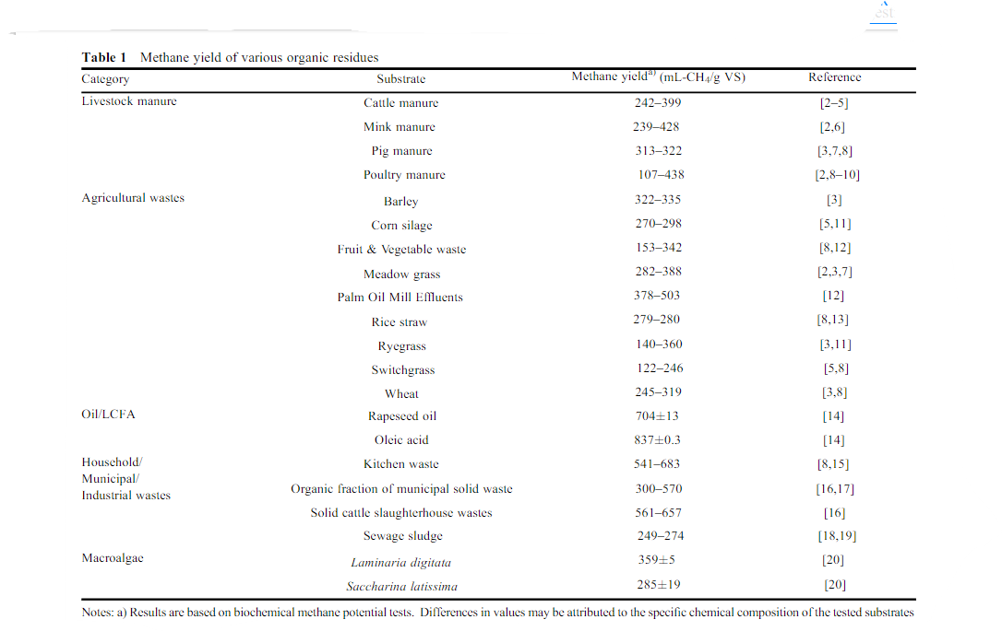

The theoretical methane yields of typical substances suitable for anaerobic digestion are presented in Table 2. Very few biogas plants apply a mono-digestion operation (i.e. the digester processes only a single feedstock).

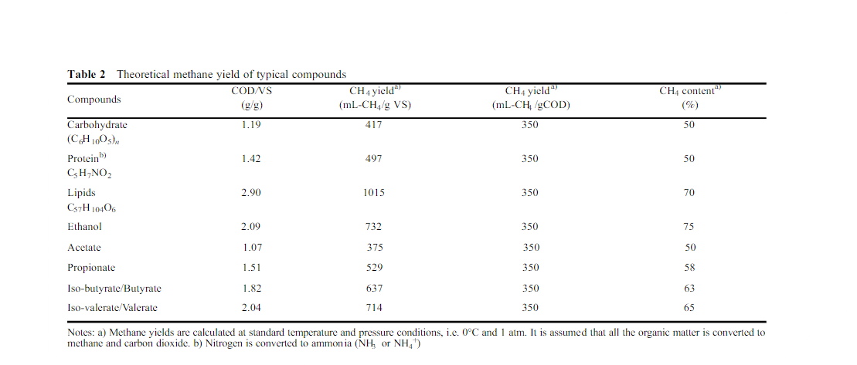

“wet fermentation”, the solids content is up to 10%, and thus the liquid content is comparatively higher [1]. The initial design of the plant’s conﬁguration is dependent on the selection between these two fermentation processes. It has to be noted that the methane yield varies signiﬁcantly among different substrates based on their chemical

“wet fermentation”, the solids content is up to 10%, and

**Manure**. is the degraded form of dead plants and animals that is added to the soil in order to boost productivity. It is a natural and cost-effective fertilizer. Manure is high in organic matter and humus, which increases soil fertility. These are better in the long term and do not pollute the environment. It is an important and renewable resource.

The agricultural state in the Philippines offers significant possibilities for bioenergy. Local governments are now taking the waste management issue seriously and taking extraordinary steps to address it. However, there is little doubt that this may be a significant role in shaping the country's destiny.

Looking back in time, the influence of the 1973 energy crisis has been felt and will continue to damage the economy. Officials have recognized the gravity of the situation and have begun to solicit suggestions to address the ever-increasing problem. The Philippine Department of Energy is interested in renewable energy resources. In reality, there exist records on the country's use of renewable energy. Look at the illustration below:

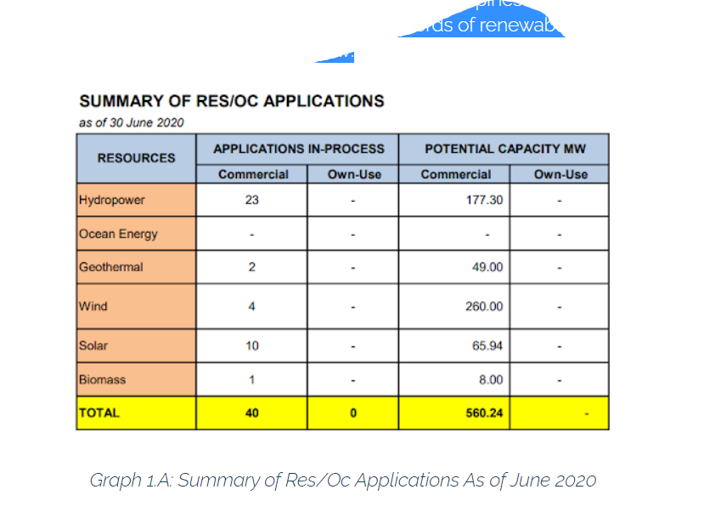

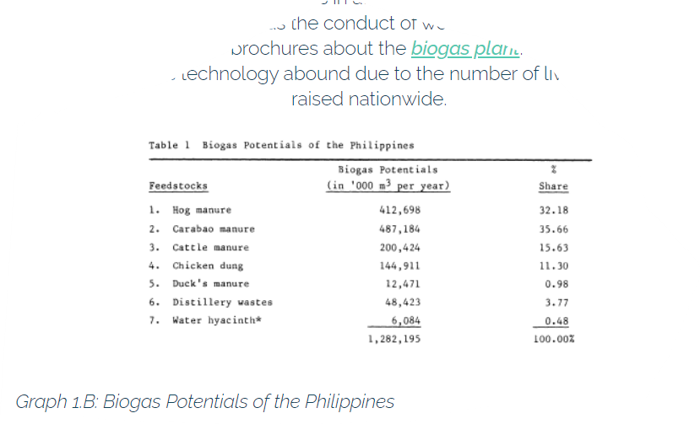

Biogas and its utilization for energy

production

Biogas and its utilization for energy

production

According to the table, the Philippines are also capable of producing biogas energy. Furthermore, increasing the number of digesters that may be utilized on agricultural land in the Philippines will boost renewable energy output. This would probably provide a look at developing the Philippines country for using renewable energy derived from garbage and will benefit the Philippines' existing ecology.

**PROCESS OF PRODUCING BIOGAS**

Biogas generation is a four-stage anaerobic breakdown process known as methane fermentation. Hydrolysis, acidogenesis, acetogenesis, and methanogenesis are the four steps. It is dependent on the symbiotic relationship between acid- and methane-producing bacteria. Bacteria consume material anaerobically (without oxygen) to create biogas. These activities occur in a variety of natural and manmade habitats, including human and animal intestines, marshes, and sewage effluent ponds.

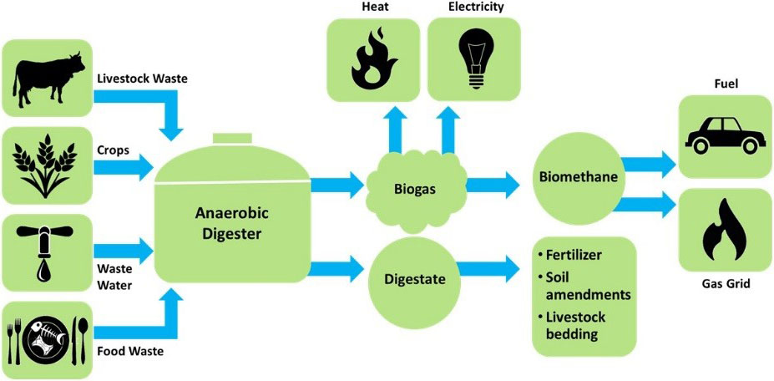

***Table 2: Illustration of a biogas system***

**References**

[**https://byjus.com/biology/biogas/**](https://byjus.com/biology/biogas/)

[**https://www.bioenergyconsult.com/a-glance-at-biomass-energy/**](https://www.bioenergyconsult.com/a-glance-at-biomass-energy/)

[**https://svs.gsfc.nasa.gov/20114**](https://svs.gsfc.nasa.gov/20114)

[**https://www.homebiogas.com/blog/the-main-uses-of-biogas/**](https://www.homebiogas.com/blog/the-main-uses-of-biogas/)

[**https://www.researchgate.net/publication/324835236_Biogas_and_its_opportunities-A_review**](https://www.researchgate.net/publication/324835236_Biogas_and_its_opportunities-A_review)

[**https://www.researchgate.net/publication/319456142_Biomass_as_Renewable_Energy**](https://www.researchgate.net/publication/319456142_Biomass_as_Renewable_Energy)

[**https://reurasia.com/the-philippines-pushes-for-biogas-energy/**](https://reurasia.com/the-philippines-pushes-for-biogas-energy/)

[**https://www.researchgate.net/publication/271834367_Design_of_the_bio-digester_for_biogas_production_A_review**](https://www.researchgate.net/publication/271834367_Design_of_the_bio-digester_for_biogas_production_A_review)